Part 4:
Sample interview sheet:
- Can you give some experiences about ordering cocktails?
- Where do you usually order from?
  - How often do you order cocktails?
- What difficulties have you met when you ordered the cocktails?
  - Difficult to find information
  - Decision making helper
- What feature do you think is the most useful function in cocktails ordering app?
  - Detailed information about cocktails
  - Users’ comments and
  - Price comparation
- How important for you to estimate your alcohol intake?
  - Would you use a feature to track your drinking capacity?
- Any additional features or improvements you would suggest for the app?
- Do you have any other comments or suggestions?
Sample Questionnaire:
- Link: https://forms.gle/snGqwcYjik1mHJiD6
Observation Guidelines Sample:
- Purpose:
- To observe and understand the feedback of current cocktail ordering solutions or prototypes, identify what the pain points and gather insights on users’ preference and behaviors.
- Preparation
    - Define the Observation Goals:
      - Find how do users using navigations.
      - Identify what factors are significant for users to order cocktails
      - Evaluate which information is necessary and useful
      - Observe engagement levels and user satisfaction.
    - Select Participants:
      - Choose a diverse group of users that represent the target audience (various ages, genders, occupations, etc.).
- Tasks
    - Define Specific Tasks:
      - Searching the specific item in the app
      - Finding relevant product with detail information (ingredients, flavor profile, reviews).
      - Use the map-based interface to find cocktails nearby.
      - Update your drinking capacity in the app.
- Analysis
    - Compile Data:
      - Organize observation notes, videos, and feedback systematically.
      - Identify common themes, pain points, and user preferences.
    - Report Findings:
      - Summarize key insights and recommendations based on observations.
      - Provide actionable suggestions for app improvements.
Low-Fidelity Prototype Sample:
1. Home Screen with Map-Based Interface
2. Cocktail Detail Page
3. User Profile with Drinking Capacity Tracker
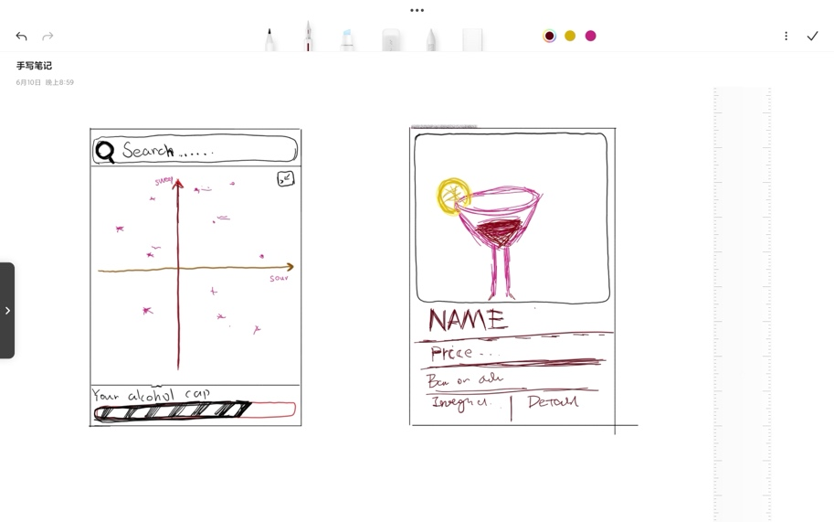
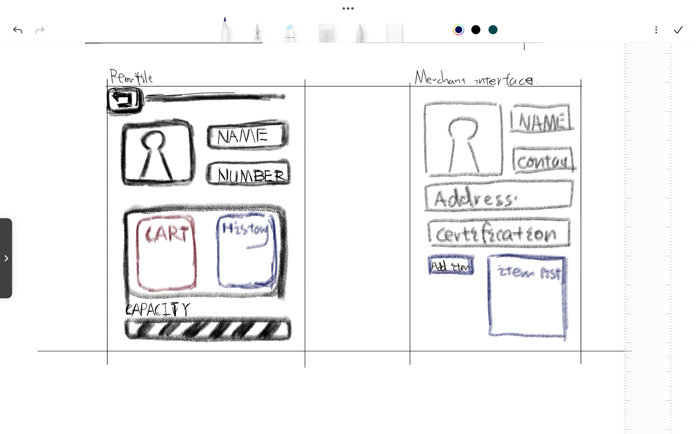
4. Merchant Interface for Menu Updates

